

CO1 – ASSIGNMENT 1

NAME: S.GANESH SAI
REG NO:192512066
COURSE CODE: ECA1302
COURSE NAME: MICROWAVE ENGINEERING

APPLICATION PROBLEM

Stage 1 – Formulating the Application and the Operating Requirement

Application, category and why it matters
The application is the antenna feed line of a UAV-mounted X-band radar used for weather avoidance and obstacle detection. I classed it as civil (with military dual use): small UAVs flying beyond visual line of sight need onboard sensing of storm cells and obstacles, and the same hardware is used on military and border-surveillance aircraft. The transmitter is a solid-state power amplifier with 500 W peak and 50 W average power (10 % duty). The feed line has three jobs: deliver that power with very little loss (every 0.1 dB lost is about 2.3 % of the transmit power and costs detection range), keep reflections low so the amplifier is not stressed, and keep the strong RF inside the line so it does not interfere with the GNSS receiver, the command-and-control datalink or the flight computer sitting nearby.
Historical background. The subject starts with Maxwell's equations in the 1860s and Hertz's laboratory demonstration of electromagnetic waves in 1887–88. Lord Rayleigh analysed waves in hollow metal tubes in 1897, which is the theoretical root of waveguide, but the idea stayed on paper until Southworth at Bell Labs and Barrow at MIT demonstrated practical waveguides in the mid-1930s. The real push came with radar: the cavity magnetron of Randall and Boot (Birmingham, 1940) produced centimetre waves at high power, and the MIT Radiation Laboratory then built a whole family of waveguide components in the 1940s. After the war came microwave relay links and satellite communication (Telstar in 1962), then planar lines

(stripline and microstrip in the 1950s) that made compact circuits possible, GaAs monolithic microwave integrated circuits (MMICs) from the 1970s and 1980s, and finally today's 5G and emerging 6G millimetre-wave systems. Our problem sits at the junction of two of those eras: a modern solid-state transmitter, but a power path where the old waveguide ideas are still the best answer.

Frequency band selection
I compared six bands for a radar with a 0.30 m antenna aperture. Wavelength is c/f, the beamwidth is estimated as θ ≈ 70λ/D, and the rain attenuation values are rounded figures for 10 mm/h rainfall taken from the order of magnitude given in ITU-R P.838 (they are indicative, not design-grade).

Band | Example f (GHz) | λ (mm) | Beamwidth, D = 0.30 m | Rain loss at 10 mm/h (dB/km) | Comment
L | 1.3 | 231 | 54° | < 0.001 | Beam far too wide; bulky
S | 3.0 | 100 | 23° | ≈ 0.005 | Penetrates rain; antenna too big
C | 5.5 | 54.5 | 12.7° | ≈ 0.04 | Moderate beam, WR-137 guide
X | 9.5 | 31.6 | 7.4° | ≈ 0.2 | Good compromise; standard WR-90
Ku | 15 | 20.0 | 4.7° | ≈ 0.5 | Narrow beam, heavy rain loss
Ka | 35 | 8.6 | 2.0° | ≈ 2 | Short range in rain, tight tolerances

I selected X band, 9.0–10.0 GHz with a centre frequency of 9.5 GHz (fractional bandwidth 10.5 %). The reasons are practical. At C band a 0.30 m antenna gives a 13° beam, too coarse to separate a pylon from a hillside. At Ku band the beam is sharper but the two-way rain loss over a 10 km path would be around 10 dB (0.5 dB/km out and back), against roughly 4 dB at X band, so storm cells behind rain would be hidden. Ka band is worse still and its tolerances are tighter. X band also contains the 9.3–9.5 GHz segment commonly used by airborne weather radar, and I widened the band to 9.0–10.0 GHz to allow frequency agility and wideband pulse compression. The wavelength of 31.6 mm also gives a manageable waveguide size.

Quantified requirement specification

Parameter | Requirement
Application and category | UAV weather and obstacle-avoidance radar feed line; civil with military dual use
Operating frequency and band | 9.0–10.0 GHz, centre 9.5 GHz; single dominant mode over the whole band
Characteristic impedance | 50 Ω at the amplifier's coaxial port; the waveguide equivalent impedance is derived in Stage 5
Maximum insertion loss | ≤ 0.30 dB over the 0.5 m run, including the transition and both flange joints
Input return loss / VSWR | ≥ 18 dB (VSWR ≤ 1.29) across 9.0–10.0 GHz
Isolation / EMI shielding | ≥ 80 dB leakage attenuation at flanges and the transition
Power level | 500 W peak, 50 W average; at least 5 times margin on peak breakdown at 6 km altitude
Size, weight, cost | Length 0.5 m; mass ≤ 200 g including flanges; unit cost ≤ ₹ 12,000 in small batches

Constraints and how they limit the choice of structure
    - EMI/EMC. The radar shares the airframe with a GNSS receiver (1.2–1.6 GHz) and a command datalink, so stray RF must stay inside the line. That points to a closed, solid-wall structure. An open microstrip line radiates and picks up interference, which is a serious mark against it.
    - Safety (power density). The ICNIRP general-public reference level at 10 GHz is 10 W/m². With 50 W average and a 0.30 m aperture of about 60 % efficiency the antenna gain is 27 dBi (534), so the power density falls to 10 W/m² at 15 m (S = PG/4πR², and 2D²/λ ≈ 5.7 m, so the far-field formula applies). I therefore specify a 15 m exclusion zone in front of the aircraft whenever it transmits on the ground. Inside the feed line itself the main safety concern is a leaking flange, which is why the 80 dB shielding requirement matters.
    - Environment. The aircraft sees −40 to +70 °C, vibration and pressure down to about 47 kPa at 6 km. Low pressure lowers the breakdown field of air, so power margin must be checked at altitude (Stage 6). Aluminium expands by about 23 ppm/K, so a ±55 K swing changes the broad dimension by only ±0.13 %.
    - Weight and cost. A UAV cannot carry a heavy feed, so brass or copper waveguide is out and thin-wall aluminium is the natural material.

Stage 1 deliverable (acceptance criteria). Application: UAV X-band radar feed → Category: civil / dual use → Band: 9.0–10.0 GHz (justified in 1.2) → Requirements: insertion loss ≤ 0.30 dB, return loss ≥ 18 dB, shielding ≥ 80 dB, 500 W peak / 50 W average → Constraints: EMI, 15 m exposure zone, altitude and weight limits → The design is accepted only if every line of the table in 1.3 is met in the Stage 6 verification.

Stage 2 – Evaluating and Selecting the Transmission Structure

Modes and field structure of each candidate at 9.5 GHz

Structure | Wave type | Dominant mode and field | Key numbers at 9.5 GHz
Coaxial line (0.141 in semi-rigid) | TEM | Radial E, circular H between inner and outer conductor; no cutoff; first higher mode TE11 | Zc = 49.9 Ω; vp = 2.10×10⁸  m/s; TE11 cutoff ≈ 34.4 GHz
Rectangular waveguide WR-90 | TE and TM | TE10: E along b, sinusoidal in x; cutoff 6.557 GHz; lowest TM mode is TM11 | λg = 43.6 mm; ZTE = 521 Ω;  vp = 4.14×10⁸ m/s
Stripline | TEM | Fields between the strip and two ground planes in a homogeneous dielectric | εeff = εr = 3.66; W ≈ 0.55 mm for 50 Ω (b = 1.016 mm)
Microstrip | Quasi-TEM | Fields partly in air, partly in the substrate; small longitudinal components | εeff = 2.85; W ≈ 1.12 mm for 50 Ω (h = 0.508 mm)

Why microstrip is quasi-TEM and not pure TEM. A pure TEM wave needs every part of the field to travel at the same phase velocity, which requires a homogeneous medium. In microstrip the field above the strip is in air (εr = 1) and the field below is in the substrate (εr = 3.66). The boundary conditions at the air–dielectric interface force the two regions to match their tangential fields, and they can only do so if small longitudinal Ez and Hz components exist, so the wave is a hybrid mode. At low frequency those components are small, and the line behaves almost like a TEM line with an effective permittivity between 1 and εr (here 2.85). As frequency rises the longitudinal fields grow, εeff climbs towards εr and dispersion appears.
Why a hollow waveguide cannot support TEM. A TEM wave has Ez = Hz = 0, so its transverse electric field satisfies Laplace's equation, Et = −∇tΦ with ∇t2Φ = 0. Φ must be constant on each conductor. A hollow guide has only one conductor, so Φ is the same constant everywhere and the transverse field is zero. A TEM mode therefore needs at least two separate conductors, as in coax and stripline.

Loss estimates used in the comparison (0.5 m run, 9.5 GHz)

Structure | Conductor (dB/m) | Dielectric (dB/m) | Per metre total | 0.5 m incl. connectors (dB)
WR-90, Ag-plated Al | 0.144 | ≈ 0 | 0.144 | 0.16
Coax, UT-141 type | 1.01 | 0.25 | 1.26 | 0.73
Microstrip, RO4350B | 7.1 | 4.8 (+0.4  radiation) | 12.3 | 6.3
Stripline, RO4350B | 14.4 | 6.1 | 20.5 | 10.3

The waveguide figure uses the formulas of Stage 4. The coax, microstrip and stripline figures come from standard closed-form expressions (coax: αc = Rs(1/a+1/b)/(2η ln(b/a)); strip lines: αc ≈ 8.686 Rs/(Z0W), αd from tan δ). They are first-order estimates, and for the planar lines they probably have an uncertainty of 20–30 %, but the conclusion does not depend on that: a 0.5 m planar line loses 6 to 10 dB, which is 20 to 30 times the waveguide. The microstrip radiation term (0.4 dB/m) is an assumption for an uncovered line.

Weighted decision matrix
Before scoring I applied a pass/fail gate using the Stage 1 insertion-loss limit of 0.30 dB. Only the waveguide passes (0.16 dB). The coax (0.73 dB), stripline and microstrip all fail it. I still scored all four, because the gate depends on the 0.5 m length and I want to see how close the contest really is. Scores run from 1 to 10 (10 is best). The loss score is calculated, not guessed: score = 10 − 9·log10(L/0.1 dB)/log10(30), clipped to 1–10. The other scores are judgement based on the figures in Stage 1 and 2.1.

Criterion | Weight | WR-90  guide | Coax | Microstrip | Stripline
Insertion loss (0.5 m) | 0.25 | 8.7 | 4.7 | 1.0 | 1.0
Power handling | 0.15 | 10.0 | 6.0 | 2.0 | 4.0
EMI shielding | 0.12 | 10.0 | 9.0 | 3.0 | 8.0
Frequency range / bandwidth | 0.10 | 8.0 | 9.0 | 6.0 | 6.0
Size / weight | 0.13 | 4.0 | 8.0 | 10.0 | 8.0
Cost | 0.10 | 5.0 | 8.0 | 9.0 | 7.0
Integration (PA to antenna) | 0.15 | 5.0 | 9.0 | 10.0 | 7.0
Overall weighted score | 1.00 | 7.45 | 7.26 | 5.21 | 5.20
Passes 0.30 dB loss gate? | – | Yes | No | No | No
Selected structure | – | Selected

The key reasoning behind the scores: the waveguide has solid walls (shielding 10), a breakdown level around 1.0 MW (power 10) and the lowest loss, but it is the heaviest option (122 g of tube) and needs a transition to the amplifier's coaxial port (size 4, integration 5). Coax is lighter and plugs straight into the amplifier but has about 4.5 times the loss. Microstrip integrates beautifully with the amplifier board but is open (shielding 3), loses several dB and cannot handle the power. Stripline is better shielded than microstrip but is even lossier because its strip must be narrow.

Sensitivity: when does the ranking reverse?
The weighted contest between waveguide (7.45) and coax (7.26) is close, so I tested it three ways (Figure 1). The ranking reverses if (a) the weight on loss drops below about 21 % (from 25 %), (b) the run length falls below about 0.26 m, because loss then matters less, or (c) the combined weights on size/weight and integration are scaled up by about 17 % or more. In every one of those cases the coax only wins on score; it still cannot meet the 0.30 dB limit unless the run is shorter than about 0.16 m. So the loss gate, not the weighted score alone, settles the choice for a 0.5 m run.
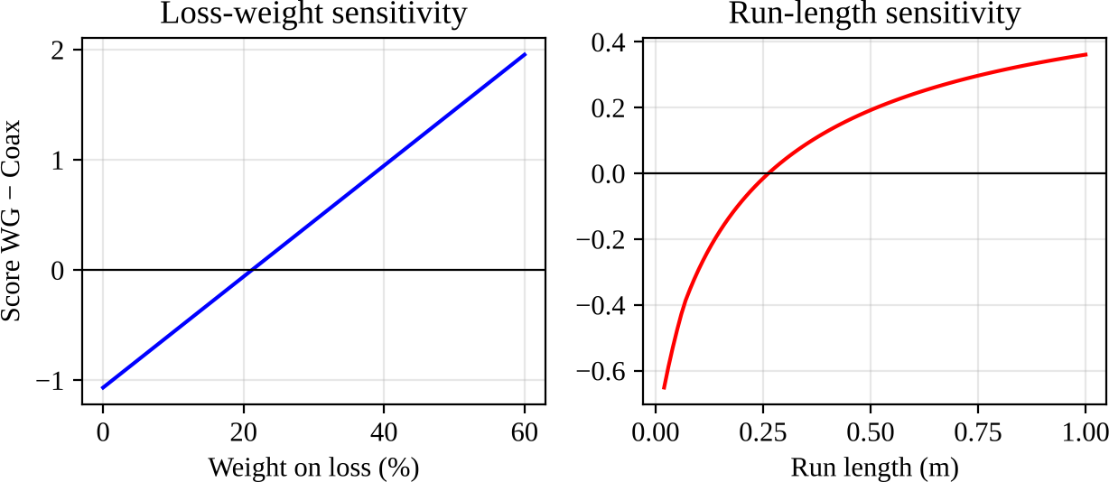

Figure 1 – Sensitivity of the waveguide-minus-coax score to the loss weight and to the run length (positive means waveguide wins).

Defending the choice against the strongest alternative
The strongest alternative is the semi-rigid coax, and I take it seriously: it is light, cheap, plugs straight in and is single-mode up to about 34 GHz. Its weakness is loss. At 9.5 GHz it dissipates
1.26 dB/m, so the 0.5 m run loses 0.73 dB including connectors, more than double the limit, and about 15 % of the 50 W average power (7.7 W) would be lost as heat in the cable and its

connectors, with a PTFE dielectric that has to survive it. In contrast the waveguide wastes 0.8 W in the walls. For a radar, a 0.55 dB difference costs roughly 3 % of detection range (range scales with the fourth root of power), which is enough to matter.
Design Decision 1. For the specified application I select WR-90 rectangular waveguide (TE10) over semi-rigid coaxial line because it is the only structure that meets the 0.30 dB loss limit at 9.5 GHz over 0.5 m (0.16 dB versus 0.73 dB), has the highest power margin and is fully shielded.
What happens if the frequency changes by a factor of two. Lowered to 4.75 GHz: WR-90 is cut off (its cutoff is 6.56 GHz), so I would need WR-187 (cutoff 3.15 GHz). It would lose only 0.040 dB/m, but the tube would weigh about 325 g, nearly three times as much, which breaks the 200 g limit. The coax, by contrast, improves to 0.84 dB/m. The size penalty is exactly what pushes the ranking towards coax at lower frequency, so the structure I did not select becomes much more attractive. Raised to 19 GHz: WR-90 would become multimode (TE20 cutoff is 13.1 GHz), so I would move to WR-42 (cutoff 14.05 GHz, 0.61 dB/m). The coax still works as a single mode (TE11 near 34 GHz) but its loss grows to 1.92 dB/m, about three times the waveguide, and microstrip and stripline reach 20 to 34 dB/m, which makes them usable only for very short on-board links.

Stage 3 – Developing the Mode and Propagation Model

Transmission-line model and the propagation constant
I start from a short length Δz of line with series resistance R and inductance L, and shunt conductance G and capacitance C, all per unit length. Applying Kirchhoff's laws to that section and letting Δz → 0 gives the telegrapher's equations:
∂v/∂z = −R i − L ∂i/∂t, ∂i/∂z = −G v − C ∂v/∂t
For a sinusoidal signal with time dependence e^{jωt} they become dV/dz = −(R + jωL) I and dI/dz
= −(G + jωC) V. Differentiating once more and substituting gives the wave equation:
d²V/dz² = γ² V, γ = α + jβ = √[(R + jωL)(G + jωC)]
The solution is V(z) = V⁺e^{−γz} + V⁻e^{+γz}, a forward and a backward wave. The characteristic impedance is Z0 = √[(R + jωL)/(G + jωC)]. When the line is low-loss (R ≪ ωL, G ≪ ωC), a binomial expansion gives:

α ≈ R/(2Z0) + G Z0/2, β ≈ ω√(LC), Z0 ≈ √(L/C)
A load ZL produces a reflection coefficient ΓL = (ZL − Z0)/(ZL + Z0), a standing-wave ratio VSWR = (1 + |Γ|)/(1 − |Γ|), and an input impedance Zin = Z0[ZL + Z0 tanh(γℓ)]/[Z0 + ZL tanh(γℓ)] at distance ℓ from the load. I use exactly these relations later in the network model, with Z0 replaced by the waveguide equivalent impedance.

Field solution for the rectangular waveguide from Maxwell's equations
For a guide filled with a lossless, homogeneous medium (ε, μ) with perfectly conducting walls and fields varying as e^{j(ωt} ⁻ ^{βz)}, Maxwell's curl equations are ∇×E = −jωμH and ∇×H = jωεE. Assuming propagation along z, the transverse components can all be written in terms of Ez and Hz. For TE modes (Ez = 0) the axial field satisfies the Helmholtz equation:
(∂²/∂x² + ∂²/∂y² + kc2) Hz = 0, kc2 = k² − β²
Separating variables and applying the boundary condition that the tangential E vanishes on the walls (x = 0, a and y = 0, b) gives Hz = A cos(mπx/a) cos(nπy/b) e^{−jβz}, with kc2 = (mπ/a)² + (nπ/b)². The transverse fields follow as Ex = (−jωμ/k ²) ∂Hz/∂y, Ey = (jωμ/k ²) ∂Hz/∂x, Hx = (−jβ/kc2) ∂Hz/∂x and Hy = (−jβ/kc2) ∂Hz/∂y. For TM modes (Hz = 0), Ez = B sin(mπx/a) sin(nπy/b) e^{−jβz} with m, n ≥ 1. The propagation constant is:
c c
β = √(k² − kc2) = k √(1 − (fc/f)²), fc = (c/2)√[(m/a)² + (n/b)²]
For the dominant TE10 mode (m = 1, n = 0) the only nonzero components are Ey = E0 sin(πx/a) e^{−jβz}, Hx = −(E0/ZTE) sin(πx/a) e^{−jβz} and Hz = (jπE0/(ωμa)) cos(πx/a) e^{−jβz}, where ZTE = ωμ/β = η/√(1 − (fc/f)²) is the TE wave impedance. For TM modes ZTM = βη/k = η√(1 − (fc/f)²). Assumptions: perfectly conducting walls for the field solution (the loss is added afterwards as a small perturbation in Stage 4), a uniform air filling (εr = 1.0006, taken as 1), a straight uniform guide with no discontinuities, and steady-state sinusoidal operation. These are reasonable for a metal tube whose skin depth (about 1 µm) is far smaller than its 1.27 mm wall.

Comparison of TEM, TE and TM modes

Mode type | Field components | Cutoff behaviour | Dispersion | Wave impedance
TEM (coax, stripline) | Ez = Hz = 0; E and H both transverse | None (works to DC) | None (vp = c/√εr) | Z = η/√εr, constant
TEmn (waveguide) | Ez = 0, Hz ≠ 0 | fc set by a, b; TE10 lowest | Strong; vp > c, vg < c | ZTE = η/√(1 − (fc/f)²) > η
TMmn (waveguide) | Hz = 0, Ez ≠ 0; m, n ≥ 1 | Lowest TM11,  16.1 GHz | Strong | ZTM = η√(1 −  (fc/f)²) < η

For this application TE10 is clearly the best mode. It has the lowest cutoff, so it is the only mode that propagates over a very wide range (6.56–13.11 GHz), its electric field is simple and linearly polarised along b (convenient for exciting the horn with a defined polarisation), and it has lower wall loss than higher modes. TM modes start at 16.1 GHz, far above our band, and TEM is not available in a hollow guide.

Dimension design
The requirement is that only TE10 propagates across 9.0–10.0 GHz with a margin. The usual rule is 1.25 fc,TE10 ≤ f ≤ 0.95 fc,TE20. The lower bound gives fc = c/2a ≤ 9.0/1.25 = 7.2 GHz, so a ≥ 20.8 mm. The upper bound gives fc,TE20 = c/a ≥ 10.0/0.95 = 10.5 GHz, so a ≤ 28.5 mm. I chose a = 22.86 mm, b = 10.16 mm, which is the standard WR-90 size. This lets me buy standard flanges and horns, and it satisfies both bounds comfortably. For b, the requirement is b < a/2 so that TE20 (13.11 GHz) is the first higher mode, not TE01 (14.75 GHz). A taller b lowers wall loss and raises power capacity but adds weight, and b = a/2.25 is a good balance.
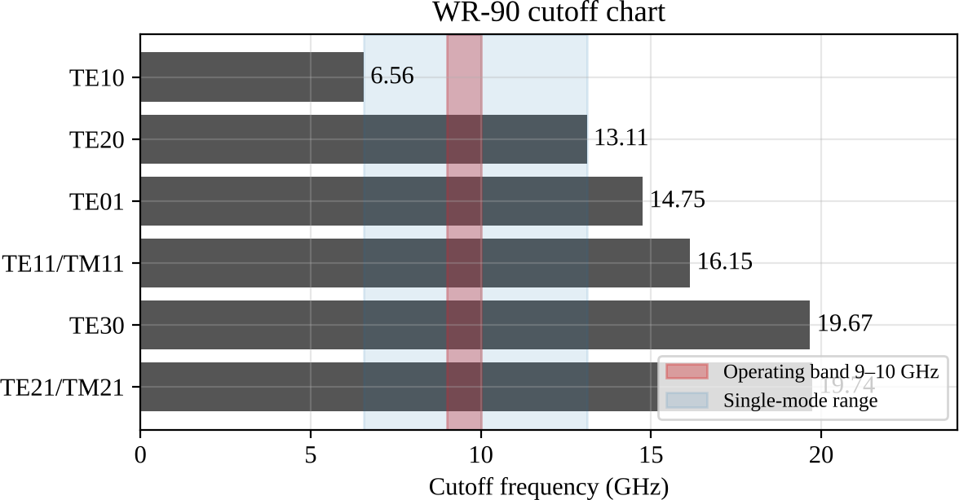

Figure 2 – Cutoff chart for WR-90. The red band is the operating band and the blue region is the single-mode range.

Parameter (WR-90, air filled) | 9.0 GHz | 9.5 GHz | 10.0 GHz
Cutoff fc (TE10) (GHz) | 6.557 | 6.557 | 6.557
fc/f | 0.729 | 0.690 | 0.656
Phase constant β (rad/m) | 129.2 | 144.1 | 158.2
Guide wavelength λg (mm) | 48.6 | 43.6 | 39.7

Parameter (WR-90, air filled) | 9.0 GHz | 9.5 GHz | 10.0 GHz
Phase velocity vp (×10⁸ m/s) | 4.377 | 4.143 | 3.971
Group velocity vg (×10⁸ m/s) | 2.053 | 2.169 | 2.263
Group delay over 0.5 m (ns) | 2.435 | 2.305 | 2.209
Wave impedance ZTE (Ω) | 550.0 | 520.6 | 499.0
Equivalent impedance Zpv (Ω) | 488.9 | 462.8 | 443.5

The single-mode range is 6.557 GHz to 13.114 GHz. The operating band sits 37 % above the TE10 cutoff and 24 % below the TE20 cutoff. The recommended range from the 1.25/0.95 rule is 8.20–12.46 GHz, and our band lies inside it. Across the band the group delay changes by 226 ps over 0.5 m, which matters only for very wide pulse-compression waveforms and can be calibrated out.

Worked calculation at 9.5 GHz (with units)
k = 2πf/c = 2π × 9.5×10⁹ / 2.998×10⁸ = 199.1 rad/m. fc = c/2a = 2.998×10⁸ / (2 × 0.02286 m)
= 6.557 GHz. fc/f = 0.6902, so √(1 − 0.6902²) = √(1 − 0.4764) = 0.7236.
β = 199.1 × 0.7236 = 144.1 rad/m. λg = 2π/β = 43.6 mm (the free-space wavelength is 31.6 mm). vp = c/0.7236 = 4.143×10⁸ m/s. vg = c × 0.7236 = 2.169×10⁸ m/s. Check: vpvg =
8.99×10¹⁶ m²/s² = c². ✓ Group delay = 0.5 m / 2.169×10⁸ m/s = 2.305 ns.

ZTE = 376.73 Ω / 0.7236 = 520.6 Ω. Zpv = (2b/a) ZTE = (2 × 10.16/22.86) × 520.6 = 0.8889 ×
520.6 = 462.8 Ω (derived in Stage 5).

Higher-order mode risk and the design change that avoids it
The structure is single-mode, but a coaxial probe, a tee junction or an imperfect flange can still excite higher modes locally. Below their own cutoff these modes do not propagate but decay quickly. At 9.5 GHz the decay rate is α = (2π/c)√(fc2 − f²), which gives 1.65 dB/mm for TE20,
2.05 dB/mm for TE01, and 2.38 dB/mm for TE11/TM11. For TE20 the field falls by 15 dB over the 9.2 mm between the stub and the horn, and it is down by about 16 dB after 1 cm and 33 dB after 2 cm. TE11 and TM11 are degenerate (they share the cutoff of 16.15 GHz), so any asymmetric feature excites both together.
To keep these modes out I made three design choices. First, the coax-to-waveguide probe is centred on the broad wall (x = a/2). TE20 has a field null at the centre, so a centred probe cannot

excite it, and the same symmetry stops the TE01 family. Second, the probe sits a quarter of a guide wavelength (about 10.9 mm) in front of the back short, where TE10 is strongest. Third, the matching stub is a symmetric H-plane tee on the narrow wall, so it does not excite TE20 and its evanescent TE30 field (cutoff 19.7 GHz, about 3 dB/mm) dies out immediately. I also kept the operating band at least 24 % below the TE20 cutoff.
Design Decision 2. The dominant mode is TE10 with cutoff frequency 6.557 GHz and upper-limit (first higher mode, TE20) frequency 13.114 GHz; the single-mode range is 6.557 GHz to
13.114 GHz; therefore the chosen dimensions (a = 22.86 mm, b = 10.16 mm) are acceptable because the 9.0–10.0 GHz band has a 37 % margin above the cutoff and a 24 % margin below the first higher-order mode.

Stage 4 – Evaluating Losses and Designing a Loss-Reduction Strategy

Loss models
Conductor loss comes from the finite conductivity σ of the walls. The skin depth is δ = 1/√(πfμ0σ) and the surface resistance is Rs = 1/(σδ) = √(πfμ0/σ). For the TE10 mode, the perturbation method (power lost in the walls divided by transmitted power) gives:
αc = Rs / (b η √(1 − (fc/f)²)) × [1 + (2b/a)(fc/f)²] Np/m
Surface roughness raises the loss. I use the Hammerstad correction Kr = 1 + (2/π) arctan[1.4(Δ/δ)²], where Δ is the RMS roughness; it saturates at 2. Dielectric loss in a filled guide is αd = k² tan δ / (2β). For an air-filled guide tan δ is of the order of 10⁻⁹, so αd is essentially zero (0.000002 dB/m). Radiation loss is nil for a closed guide apart from flange leakage, which I take as 0.0005 dB with gasketed flanges. Connector and transition losses are lumped values (assumptions based on typical coax-to-waveguide adapters): initial design 0.18 dB for the transition and 0.02 dB per flange; improved design 0.07 dB and 0.01 dB. Mismatch loss is ML
= −10 log10(1 − |Γ|²), which is power reflected rather than dissipated.

Worked calculation of conductor and dielectric attenuation
Initial design (aluminium 6061, σ = 2.5×10⁷ S/m, Δ = 1.6 µm). δ = 1/√(π × 9.5×10⁹ × 4π×10⁻⁷ × 2.5×10⁷) = 1.033 µm. Rs = 1/(σδ) = 38.73 mΩ. With fc/f = 0.6902 and 2b/a = 0.8889, the bracket is 1 + 0.8889 × 0.4764 = 1.4235, and the denominator is bη√(...) = 0.01016 × 376.73 × 0.7236 = 2.770 Ω·m. So αc (smooth) = 0.03873/2.770 × 1.4235 =
0.01991 Np/m = 0.173 dB/m. The roughness ratio is Δ/δ = 1.6/1.033 = 1.549, so Kr = 1 +

(2/π) arctan(1.4 × 1.549²) = 1 + 0.6366 × 1.279 = 1.816, and αc = 0.173 × 1.816 = 0.314

dB/m.
Improved design (silver plated, σ = 6.1×10⁷ S/m, Δ = 0.4 µm): δ = 0.661 µm, Rs = 24.8 mΩ, smooth αc = 0.111 dB/m, Kr = 1.301, so αc = 0.144 dB/m.
Dielectric example. To show why I keep the guide empty, suppose it were PTFE-filled (εr = 2.1, tan δ = 2×10⁻⁴). Then k = 2π × 9.5×10⁹ × √2.1 / c = 288.5 rad/m, the cutoff drops to 4.524 GHz, β = 288.5 × √(1 − (4.524/9.5)²) = 253.7 rad/m, and αd = k²tan δ/(2β) = (288.5² ×
2×10⁻⁴)/(2 × 253.7) = 0.0328 Np/m = 0.285 dB/m, which is already more than the entire
improved conductor loss.

Parametric study
Figure 3 shows the attenuation of the TE10 mode against frequency for several wall materials. Wall loss falls gently across the band (from 0.332 to 0.301 dB/m for the initial design) because the denominator √(1 − (fc/f)²) grows faster than √f. At 9.5 GHz the material ranking for smooth walls is silver 0.111, copper 0.114, aluminium 0.173, brass 0.223 and stainless steel 0.731 dB/m. Aluminium is only about 50 % worse than copper and weighs a third as much, which is why I keep it as the base metal and add a thin silver layer where the current flows.
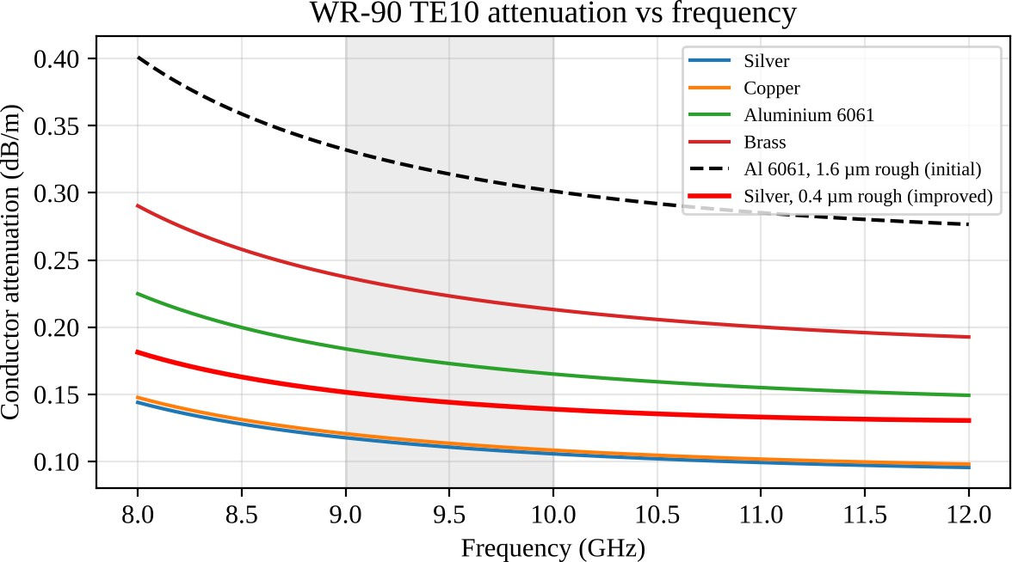

Figure 3 – WR-90 TE10 conductor attenuation versus frequency for different wall materials (operating band shaded).

RMS roughness (µm) | 0 | 0.4 | 0.8 | 1.6 | 3.2
Aluminium (dB/m) | 0.173 | 0.196 | 0.250 | 0.314 | 0.338

RMS roughness (µm) | 0 | 0.4 | 0.8 | 1.6 | 3.2
Silver (dB/m) | 0.111 | 0.144 | 0.189 | 0.213 | 0.219

Roughness matters a lot for aluminium: at 1.6 µm (a typical machined bore) the loss is 1.82 times the smooth value, because the roughness is larger than the skin depth. Polishing to 0.4 µm recovers most of it. For the dielectric loss tangent (Figure 4, right) I assumed a filled guide; with tan δ = 10⁻⁴, 2×10⁻⁴, 10⁻³ and 4×10⁻³ the loss would be 0.14, 0.29, 1.43 and 5.70 dB/m, and it rises linearly with tan δ. The trend confirms that an air-filled guide eliminates this mechanism entirely.
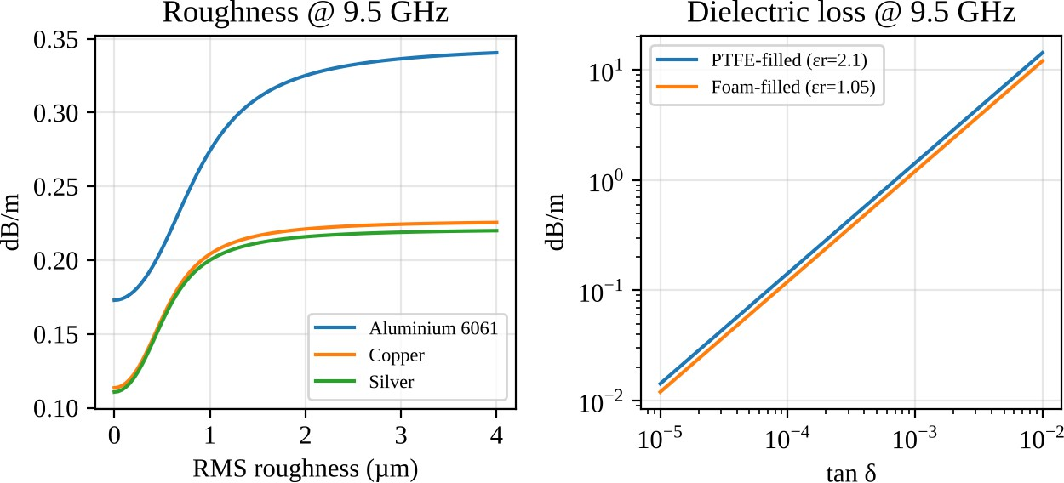

Figure 4 – Left: effect of RMS roughness on attenuation at 9.5 GHz. Right: dielectric attenuation of a filled guide versus loss tangent.

Loss budget, dominant loss and redesign

Loss component | Initial design (dB/m) | Improved design (dB/m) | % of total (initial → improved) | Trade-off / remarks
Conductor loss | 0.314 | 0.144 | 21.0 → 43.8 | Silver plating (5 µm, about 7δ) and polishing; adds cost, silver tarnishes so needs a passivation layer
Dielectric loss | ≈ 0.000 | ≈ 0.000 | ≈ 0 → ≈ 0 | Air filled; zero cost but no pressurisation window allowed
Radiation loss | 0.001 | 0.001 | 0.07 → 0.30 | Closed guide; flange leakage with gasket
Connector / transition loss | 0.440 | 0.180 | 29.4 → 54.8 | Precision transition and flatter flanges cost more; lumped over 0.5 m

Loss component | Initial design (dB/m) | Improved design (dB/m) | % of total (initial → improved) | Trade-off / remarks
Mismatch loss (horn) | 0.743 | 0.004 | 49.6 → 1.1 | Single stub removes it but narrows bandwidth and adds tolerance sensitivity
Total attenuation | 1.498 | 0.329 | 100 → 100 | Over 0.5 m: 0.749 dB →  0.164 dB

The table is expressed per metre, so the lumped losses (connectors, mismatch) have been divided by the 0.5 m length; the last row shows the real totals over the run. The dissipative part alone (conductor, connectors, radiation) is 0.377 dB initially and 0.163 dB after the redesign.
Dominant loss. In the initial design the dominant mechanism is the mismatch at the horn,
49.6 % of the total. Surprisingly, the metal is not the problem: conductor loss is only 21.0 %. If I ignore mismatch and count only dissipation, the transition and flanges (29.4 %) still beat the conductor. I would not have guessed this before doing the budget, since waveguide is usually praised for its low wall loss.
Redesign. I adopted three measures together: (1) a matching stub to remove the horn mismatch (designed in Stage 5), (2) silver plating of the inner walls with a polished 0.4 µm finish, which cuts conductor loss from 0.314 to 0.144 dB/m, and (3) a precision transition and flat gasketed flanges. The total falls from 0.749 dB to 0.164 dB, an improvement of 0.58 dB. Over the band the worst-case total is 0.232 dB.
Judgement. The improved design meets the 0.30 dB limit with a margin of 0.07 dB in the worst band edge. The trade-offs are higher unit cost (plating), a slightly narrower matched bandwidth, and a stub whose dimensions must be held tightly (Stage 6).
Design Decision 3. The dominant loss mechanism is mismatch at the horn contributing 49.6
% of the total; the loss-reduction measure I adopt is a single shunt stub match combined with silver plating and a precision transition, which reduces the attenuation from 0.749 to

0.164 dB.

Stage 5 – Creating and Evaluating the Network Model

Equivalent voltage and current for a non-TEM line
On a TEM line, voltage is the line integral of E between the conductors and it does not depend on the path, because there is no longitudinal magnetic field. In a waveguide it does depend on the path, since ∇×E = −jωμH has a nonzero Hz, so the integral of E around a closed loop is not zero. The current is also ambiguous: it could be the total axial current in the broad wall, or the current per unit width. There is therefore no unique V or I, and the impedance depends on the definition I choose.
The usual remedy, which I follow, is to define equivalent V and I so that they obey the transmission-line equations and carry the correct power. For TE10, with Ey = E0 sin(πx/a)e^{−jβz}, I define the voltage at the centre of the broad wall as V = E0b. The power flowing in the guide is P = (1/2)∬Re(E×H*)·dS = abE02/(4ZTE). Setting P = V²/(2Zpv) gives the power–voltage equivalent impedance:
Zpv = V²/(2P) = (2b/a) ZTE = (2b/a) η/√(1 − (fc/f)²)
At 9.5 GHz this is 462.8 Ω (it varies from 488.9 Ω at 9 GHz to 443.5 Ω at 10 GHz). Different definitions (power–current, voltage–current) would differ by a constant factor, but this factor cancels in any ratio of impedances. That is why I use normalised impedances and take the port reference impedance equal to the line's own Zpv(f), which is what full-wave solvers do for waveguide ports. The equivalent line has propagation constant γ = αc + jβ and characteristic impedance Zpv.

Normalised wave variables
With a reference impedance Z0, the incident and reflected wave amplitudes at a port are: a = (V + Z0 I) / (2√Z0), b = (V − Z0 I) / (2√Z0)
so that V = √Z0(a + b), I = (a − b)/√Z0, the net power is P = (|a|² − |b|²)/2, and the reflection coefficient is Γ = b/a. The scattering matrix links the waves, b1 = S11a1 + S12a2 and b2 = S21a1
+ S22a2, where S11 = b1/a1 with a2 = 0 (port 2 matched) and so on. Insertion loss is IL = −20 log|S21| and return loss is RL = −20 log|S11|.

Two-port model and cascade
Each element of the feed is a two-port with an ABCD matrix. A line section of length ℓ and impedance Zc is [cosh γℓ, Zc sinh γℓ; sinh γℓ / Zc, cosh γℓ]. A shunt admittance Y is [1, 0; Y, 1]. For a short-circuited stub of length ℓs, Y = 1/(Zc tanh γℓs) = −jYc cot βℓs when the loss is

neglected. The transition and flanges are modelled as a matched two-port with S21 = 10^{−IL/20} (an assumption; its own reflection is neglected here and discussed in Stage 6). The cascade (Figure 5) is the product of the matrices, and the S-parameters follow from the standard conversion:
S11 = (A + B/Z0 − CZ0 − D)/Δ, S21 = 2/Δ, S12 = 2(AD − BC)/Δ, S22 = (−A + B/Z0 − CZ0
+ D)/Δ
where Δ = A + B/Z0 + CZ0 + D. For a uniform lossless line section matched to its own Zc this gives S11 = S22 = 0 and S21 = S12 = e^{−jβℓ}, which is a useful check on the code.

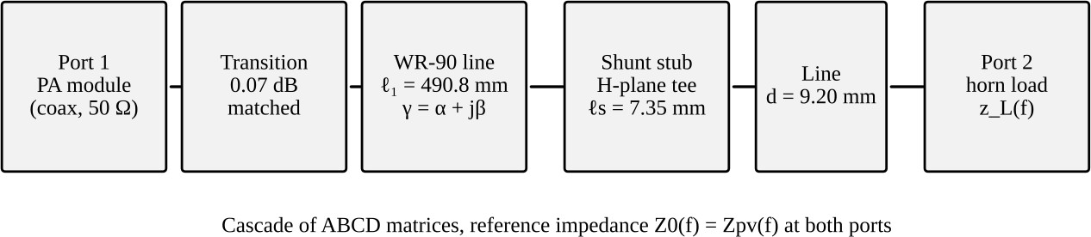

Figure 5 – Network model of the feed: transition, line, shunt stub, short line and the horn load.

Input impedance, reflection and VSWR for a realistic load
The horn input impedance is not 1 (matched). I took it as a normalised zL(f) = 1.35 + j0.6 (f/9.5 GHz), that is a slightly high resistance and an inductive reactance that grows with frequency. This is an assumed model of a real horn throat, and it should be replaced with a measured S11 when a horn is available. At 9.5 GHz, ΓL = (zL − 1)/(zL + 1) = (0.35 + j0.60)/(2.35 + j0.60), so
|ΓL| = 0.6946/2.4254 = 0.286 at 45.4°. That gives VSWR = (1 + 0.2864)/(1 − 0.2864) = 1.80,
RL = −20 log(0.2864) = 10.86 dB and mismatch loss ML = −10 log(1 − 0.2864²) = 0.372 dB. Across 9–10 GHz the return loss is 11.2, 10.9 and 10.6 dB at 9.0, 9.5 and 10.0 GHz. This fails the 18 dB requirement by a wide margin, so a match is required.

Matching design (single shunt stub)
A quarter-wave transformer cannot match a complex load on its own, because it only transforms resistances, and a taper would need several guide wavelengths of length. A single shunt stub is simple, short and is easily built as an H-plane tee. The method is: find the distance d from the load where the normalised input admittance has a real part of 1, then cancel its imaginary part with a short-circuited stub.

Moving towards the generator, Γ(d) = ΓLe^{−j2βd} and y(d) = (1 − Γ(d))/(1 + Γ(d)). At 9.5 GHz the first point where Re y = 1 is at d = 9.21 mm (0.211 λg), where y = 1 + j0.598. The stub must supply −j0.598, so −cot(βℓs) = −0.598, giving βℓs = arccot(0.598) = 1.032 rad (59.1°) and ℓs = 1.032/144.07 = 7.16 mm (0.164 λg). This closed-form design gives an essentially perfect match at 9.5 GHz (RL above 70 dB) but the worst return loss in the band is only 17.1 dB at the band edges. Since the specification applies to the whole band, I then ran a numerical minimax optimisation (Nelder–Mead) of d and ℓs to maximise the worst-case return loss over 9.0–10.0 GHz. The result is d = 9.20 mm and ℓs = 7.35 mm, with a worst-case return loss of 18.18 dB at both band edges and 35.3 dB at the centre.

Results: before and after matching

Parameter (9.5 GHz unless stated) | Before matching | After matching | Target | Interpretation
Reference impedance Z0 (Ω) | 462.8 | 462.8 | Zpv | Equivalent line impedance; 50 Ω at coax port
|Γ| / VSWR at horn plane | 0.286 / 1.80 | 0.017 / 1.04 | VSWR ≤  1.29 | Match achieved at centre
Worst |Γ| / VSWR over band | 0.297 / 1.84 | 0.123 / 1.28 | ≤ 1.29 | Just meets target at the band edges
Return loss at centre (dB) | 10.9 | 35.3 | ≥ 18 | Pass after matching
Worst return loss in band (dB) | 10.6 | 18.2 | ≥ 18 | Pass, margin only 0.18 dB
Insertion loss, power to horn (dB) | 0.749 (0.72–  0.78) | 0.164 (0.16–  0.23) | ≤ 0.30 | Fail before, pass after
Reciprocity |S12 − S21| | 2×10⁻¹⁶ | 3×10⁻¹⁶ | 0 | Reciprocal (passive, isotropic)
Lossless check 1 −  |S11|² − |S21|² | 0.083 | 0.039 | 0 if lossless | Positive: power dissipated in walls and transition

I report return loss at the horn plane because it is the conservative reference: at the generator port, the line and transition attenuation (about 0.2 dB round trip) makes the return loss look slightly better (11.6 dB before and 35.5 dB after at 9.5 GHz). The insertion loss in the table is the power not delivered to the horn, relative to the available power. It equals the sum of the budget items from Stage 4 (0.377 dissipative + 0.372 mismatch = 0.749 dB), which is a useful consistency check.

Reading the S-parameters. Reciprocity holds to machine precision, as expected for a passive, isotropic waveguide structure. The line and transition alone are symmetric (S11 = S22); once the stub is added the network is no longer symmetric (S11 ≠ S22) because the stub sits 9.2 mm from the horn side and not in the middle. The network is lossy, not lossless: the dissipated fraction 1 − |S11|² − |S21|² is 8.3 % before and 3.9 % after (the sum of the line, transition and flange losses). By itself the stub network has S11 = -11.7 dB at 9.5 GHz, which looks poor, but this is intentional: the stub is a reactive element placed to cancel the horn's reactance and it only gives a good match when the horn is connected. That is why I judged S21 for the line alone (0.072 dB for the plated line, 0.157 dB for the aluminium one) and used the transducer loss with the horn for the system.
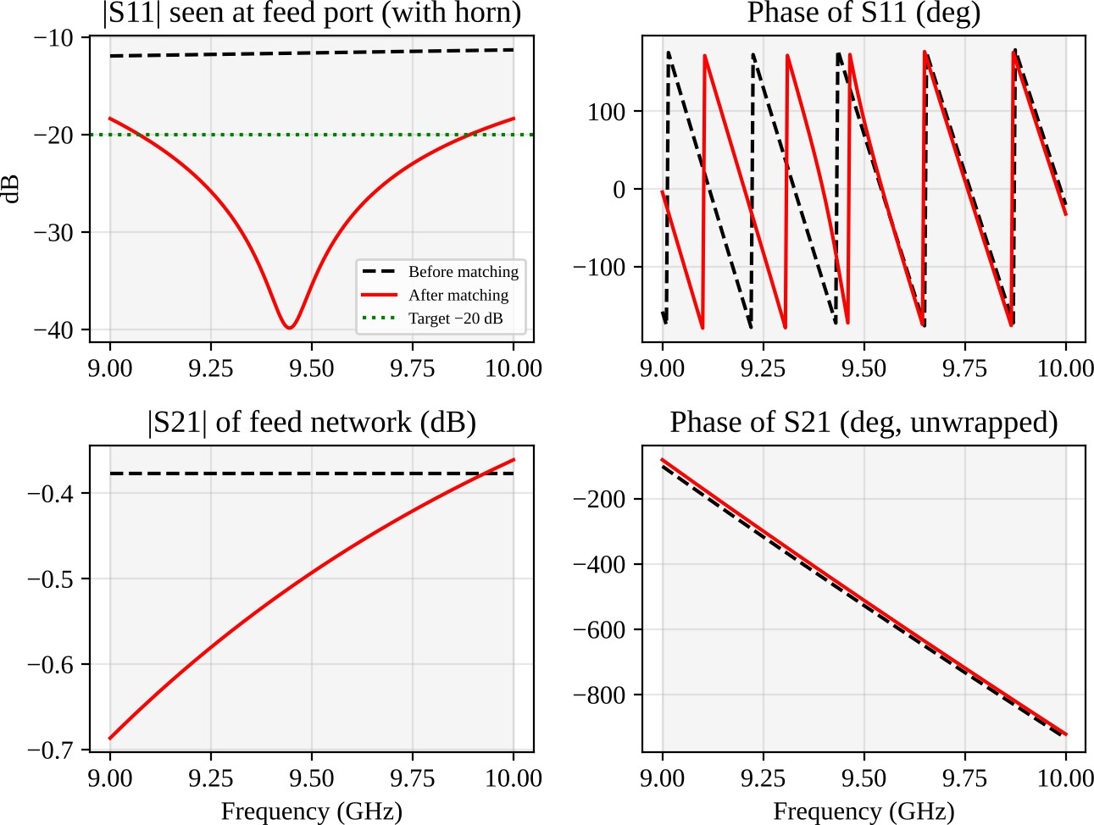
Figure 6 – Magnitude and phase of S11 (seen at the feed port with the horn) and S21 of the feed, before and after matching, 9–10 GHz.

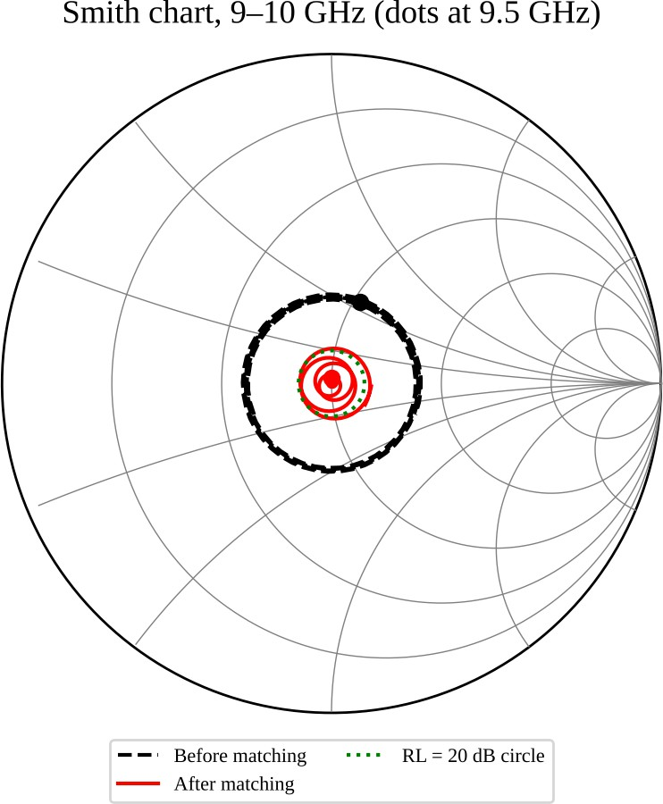
Figure 7 – Smith chart of the input reflection coefficient before and after matching; the green circle is the 20 dB return-loss circle.

Independent verification
I computed the return loss of the matched design three different ways: (a) a direct impedance transformation (move the load through d, add the stub admittance, move through the rest of the line, convert to Γ), (b) my ABCD cascade with the S-parameter conversion, and (c) scikit-rf (version 2.2.0), which builds networks from lines, a shunt short-circuited stub and a load and cascades them with its own routines.

Frequency (GHz) | Direct (dB) | ABCD cascade (dB) | scikit-rf (dB)
9.00 | 18.181 | 18.181 | 18.181
9.25 | 25.654 | 25.654 | 25.654
9.50 | 35.273 | 35.273 | 35.273
9.75 | 22.800 | 22.800 | 22.800
10.00 | 18.181 | 18.181 | 18.181

The three agree to better than 10⁻⁹ dB at every frequency tested. I want to be honest that this verifies the algebra and the code, not the physical assumptions (the idealised horn, the matched transition), which only a full-wave model or a measurement can check.

Worked hand calculation (stub position, 9.5 GHz). Already shown in 5.4 and 5.5: ΓL = 0.286∠45.4°, d = 9.21 mm, y(d) = 1 + j0.598, ℓs = 7.16 mm for the exact-centre match.

Stage 6 – Validating, Critiquing and Defending the Final Design

Specification verification table

Requirement | Specified | Initial design | Final design (worst case) | Satisfied?
Operating band / single-mode range | 9–10 GHz,  single mode | 6.56–13.11 GHz | 6.56–13.11 GHz;  ±5 % on a keeps band inside | Yes / Yes
Dominant mode and cutoff | TE10, fc well below 9 GHz | TE10, 6.557 GHz | TE10, 6.24–6.90  GHz for ±5 % on a | Yes / Yes
Insertion loss / attenuation | ≤ 0.30 dB | 0.75 dB | 0.23 dB (band), about 0.25 dB with  tolerance | No / Yes
Impedance / VSWR | VSWR ≤  1.29 | 1.80 (worst  1.84) | 1.28 nominal; 1.33  as machined; 1.28 trimmed | No / Yes (trimmed)
Return loss S11 | ≥ 18 dB | 10.6 dB | 18.2 nominal; 17.0  as machined; 18.1 trimmed | No / Yes (trimmed)
EMI shielding / isolation | ≥ 80 dB | 60–70 dB (est., flat flanges) | ≥ 90 dB expected with gaskets (to be tested) | No / Yes (to verify)
Power handling / size | 500 W peak, 50 W avg; ≤ 200 g | 1.0 MW at sea level; 158 g | 0.22 MW at 6 km  (≈ 443× margin);  0.8 W dissipated;  158 g | Yes / Yes

Notes on the table. Breakdown power uses the textbook TE10 expression P = abEbr2/(4ZTE) with Ebr = 3 MV/m for air, scaled with pressure squared to 47 kPa at 6 km. The mass is the 122 g tube (1.27 mm walls) plus an allowance of 18 g for each flange. The unit cost estimate of about
₹ 9,000 (tube, plating, precision transition, flanges) is my own estimate and should be confirmed with a quotation. The shielding values are engineering estimates for gasketed and ungasketed flanges, not calculations; the test plan below is how they will be proven.

Critique of assumptions
    - Ideal conductor (PEC) in the field solution. Valid because the skin depth is about 1 µm; the effect of the real walls is included separately as αc. The error in the mode parameters is well below 0.1 %.
    - Uniform dielectric and frequency-independent εr. Air filling makes this nearly exact. It would not hold for the planar alternatives or for a filled guide.
    - Neglected discontinuities. This is the biggest assumption. I treated the coax-to-waveguide transition as a matched lossy block and the stub tee as an ideal shunt element. A real tee has a junction reactance, which shifts the required stub length by a few tenths of a millimetre, and a real transition has its own reflection. If the transition has a return loss of 30 dB (|Γ| = 0.032) and its reflection lines up in phase with the residual mismatch (|Γ| = 0.123), the worst-case combined return loss would drop from 18.2 dB to about 16.2 dB. This is why I recommend an adjustable stub.
    - Horn model. The horn load zL(f) is an assumed model. A measured horn will have a different frequency dependence, and the stub should be re-optimised against measured data.
    - Rough-wall model and lumped losses. The Hammerstad model and the lumped transition and flange losses are typical values, probably good to ±30 %. They do not change any conclusion because the total is 0.164 dB against a 0.30 dB limit.

Tolerance and robustness
I perturbed the model with ±5 % errors in a, b, the stub position d and the stub length ℓs, in all 16 corner combinations, and recorded the worst-case return loss over 9–10 GHz. I should be clear that ±5 % is a stress test, not a realistic tolerance: a precision WR-90 tube is made to about ±0.05 mm (0.2 %). Three levels are reported.

Case | Worst RL (dB) | Comment
Nominal design | 18.18 | Just meets 18 dB
Machining-grade: a, b ±0.05 mm;  d, ℓs ±0.1 mm | 16.96 | VSWR 1.33; about 1 dB short of the target
Same, with stub length trimmed (±3 mm plunger) | 18.11 | Meets the target again
Stress test: ±5 % on a, b, d, ℓs (worst corner) | 11.37 | Best corner 18.1 dB; trimming recovers it to 16.0 dB

The individual ±5 % effects on the return loss are: a: 13.7 dB (−5 %) and 16.1 dB (+5 %); d:
16.1 and 16.4 dB; ℓs: 16.1 and 16.6 dB; b has almost no effect (18.2 dB), because it scales the line impedance and the horn normalisation together. The broad dimension a is the most sensitive because it moves the guide wavelength, and so the electrical length of d and ℓs. The mode behaviour itself is robust: with a ±5 %, the cutoff moves between 6.24 and 6.90 GHz, the first higher mode (TE20) stays between 12.5 and 13.8 GHz, the impedance Zpv between 423 and 513 Ω, and the conductor loss between 0.133 and 0.159 dB/m. The band therefore always remains single-mode. The ±55 K temperature range changes a by only ±0.13 %, which is negligible. One further point: a ±5 % error in a changes the electrical length of the 0.5 m run by about 208°, which does not affect return loss in a single channel but would matter if several feed lines had to be phase-matched in an array.

EMC and safety
Shielding is set by the weakest joint, not by the 1.27 mm aluminium wall (which is more than 1000 skin depths thick and effectively perfect). I will use conductive-elastomer gaskets on every flange, flat and clean mating faces, bolts at every flange hole, and a coax connector with a proper torque spec at the transition. The tube is bonded to the airframe at both ends through the flanges, so the guide acts as a continuous shield. A second-harmonic problem exists: the 19 GHz second harmonic is above the TE20 cutoff and propagates in WR-90, so a harmonic filter should follow the amplifier to meet the spurious-emission mask. For human exposure, the 10 W/m² limit leads to the 15 m ground exclusion zone from Stage 1.
Basic EMC and safety test plan. (1) Flange leakage: measure the leakage attenuation with a probe and receiver (sniffer test) around each joint, and as a system test with the feed in a shielded enclosure following IEEE Std 299; target ≥ 80 dB. (2) Radiated emissions of the integrated radar to the applicable limit (RTCA DO-160 Section 21 for civil aircraft, or MIL-STD-461 RE102 for military use). (3) Power density: measure the average density with a calibrated broadband probe at the exclusion distance and at the pilot and ground-crew positions.
(4) Environmental: thermal and vibration tests (DO-160 Sections 4 and 8) with a VNA sweep before and after to catch any change in S11.

Improved design and experimental test plan
The most serious limitation is that the fixed stub gives only 17.0 dB in the as-machined worst case, a miss of about 1.0 dB, and it has no margin for the transition's own reflection. My improvement is to make the stub adjustable, using a short-circuit plunger or tuning screw with

about ±3 mm travel, and to specify the transition to have a VSWR no worse than 1.05 (RL ≥ 32 dB). The plunger is trimmed once on a vector network analyser, which recovers 18.1 dB from the as-machined worst case in my model. If a wider matched band were needed, a double-stub tuner or a short tapered throat on the horn would be the next step, but I have not designed or simulated those, so I regard them as options and not as results.
Experimental test plan. (1) Calibrate a VNA in WR-90 (TRL or through-reflect-line) and measure S11 and S21 of the assembled feed with the horn from 8.5 to 10.5 GHz; accept if RL ≥ 18 dB and S21 ≥ −0.30 dB over 9–10 GHz. (2) Measure the unmatched horn first, and use that data to re-optimise d and ℓs. (3) Measure phase and group delay to compare with the 2.305 ns calculated at 9.5 GHz. (4) Run a high-power test at 500 W peak, 10 % duty for one hour, with a thermal camera on the tube and flanges (only about 0.8 W is dissipated in the walls, so any hot spot would point to a bad joint). (5) Repeat after thermal cycling and vibration.

Final Engineering Decision

Should this structure and mode be adopted for the application?
- Initial design: NO. The initial aluminium WR-90 feed with an ordinary transition and the unmatched horn loses 0.75 dB, which is 2.5 times the 0.30 dB limit, and its return loss is 10.6 dB against the 18 dB requirement (VSWR 1.84). The dominant loss is the horn mismatch (50
% of the total); the shielding with flat flanges is also not guaranteed to reach 80 dB. The structure and mode are right, but this implementation does not pass.
- Final design: YES, conditional on an adjustable stub. The WR-90, TE10 design with silver-plated polished walls, a precision transition, gasketed flanges and a shunt stub (d = 9.20 mm, ℓs = 7.35 mm) is accepted, based on the following evidence from Stages 1–6.
  - Compliance with each specification. Insertion loss 0.23 dB worst in band (limit 0.30); return loss 18.2 dB worst nominal and 35.3 dB at centre (limit 18); power margin about 443 times at 6 km; mass 158 g (limit 200); shielding expected ≥ 90 dB with gaskets (to be tested).
  - Dominant loss. Mismatch (50 %) has been removed. What remains is dominated by the transition and flanges (55 % of 0.164 dB) and the plated wall (44 %). Both are small.
  - Single-mode margin. The band is 37 % above the TE10 cutoff and 24 % below TE20, and it stays single-mode for ±5 % on a.

  - Matching. The stub gives 35.3 dB at the centre and 18.2 dB at the edges, a margin of only 0.18 dB on the nominal design.
  - EMC behaviour. A closed metal guide with gasketed flanges keeps the RF inside; the harmonic filter and exclusion zone handle emissions and exposure.
  - Tolerance sensitivity. As machined, the worst case is 17.0 dB, about 1 dB under the target. This is why the decision is conditional: with the adjustable stub trimmed on a VNA it recovers to 18.1 dB.
Remaining non-compliance and further change (the "if NO" part, applied to the fixed-stub version). A fixed stub as machined does not meet 18 dB in every corner, and the transition's own reflection could take it lower. The further change is an adjustable stub plus a transition specified at VSWR ≤ 1.05, as described in 6.5. I predict that this leaves the insertion loss essentially unchanged (below 0.01 dB extra, since a plunger adds a small contact resistance), lets the return loss reach at least 18 dB in the as-built unit (my model gives 18.1 dB), and does not change the mode behaviour at all, because the guide dimensions are untouched. If a later system change demanded a wider band or tighter return loss, the next step would be a double-stub or tapered-throat matching section.

References
- D. M. Pozar, Microwave Engineering, 4th ed., Wiley, 2012.
- R. E. Collin, Foundations for Microwave Engineering, 2nd ed., IEEE Press / Wiley, 2001.
- S. Ramo, J. R. Whinnery and T. Van Duzer, Fields and Waves in Communication Electronics, 3rd ed., Wiley, 1994.
- N. Marcuvitz (ed.), Waveguide Handbook, MIT Radiation Laboratory Series, vol. 10, McGraw-Hill, 1951.
- E. Hammerstad and O. Jensen, “Accurate Models for Microstrip Computer-Aided Design,” IEEE MTT-S International Microwave Symposium Digest, 1980.
- Lord Rayleigh, “On the passage of electric waves through tubes, or the vibrations of dielectric cylinders,” Philosophical Magazine, 1897.
- ITU-R Recommendation P.838-3, Specific attenuation model for rain for use in prediction methods, 2005.

- ICNIRP, “Guidelines for Limiting Exposure to Electromagnetic Fields (100 kHz to 300 GHz),” Health Physics 118(5), 2020.
- IEEE Std 299, Standard Method for Measuring the Effectiveness of Electromagnetic Shielding Enclosures.
- RTCA DO-160, Environmental Conditions and Test Procedures for Airborne Equipment (Sections 4, 8 and 21).
- A. Arsenovic et al., “scikit-rf: An Open Source Python Package for Microwave Network Creation, Analysis, and Calibration,” IEEE Microwave Magazine, 2022.

Appendix A – Python Code (key functions)
The full script (calc.py) also generates all figures; the essential functions are listed here. Libraries: NumPy, SciPy, scikit-rf.
import numpy as np
c = 299792458.0; mu0 = 4e-7*np.pi; eta0 = 376.730313
a, b = 22.86e-3, 10.16e-3 # WR-90 inner dimensions (m)

def fc(m, n, a=a, b=b): # cutoff of TE/TM_mn return 0.5*c*np.sqrt((m/a)**2 + (n/b)**2)
def guide(f, a=a, b=b): # TE10 propagation parameters r = np.sqrt(1 - (fc(1, 0, a, b)/f)**2)
beta = 2*np.pi*f/c*r zte = eta0/r
return dict(beta=beta, lam_g=2*np.pi/beta, vp=c/r, vg=c*r, zte=zte, zpv=2*b/a*zte)

def Rs(f, s): return np.sqrt(np.pi*f*mu0/s) # surface resistance def delta(f, s): return 1/np.sqrt(np.pi*f*mu0*s) # skin depth
def Kr(f, s, rough): return 1 + 2/np.pi*np.arctan(1.4*(rough/delta(f, s))**2)

def alpha_c(f, s, rough=0.0, a=a, b=b): # TE10 conductor loss, Np/m r = np.sqrt(1 - (fc(1, 0, a, b)/f)**2)
al = Rs(f, s)/(b*eta0*r)*(1 + 2*b/a*(fc(1, 0, a, b)/f)**2) return al*Kr(f, s, rough)

def abcd_line(zc, gl): # gl = gamma*length return np.array([[np.cosh(gl), zc*np.sinh(gl)],
[np.sinh(gl)/zc, np.cosh(gl)]], dtype=complex)

def abcd_shunt(Y): return np.array([[1, 0], [Y, 1]], dtype=complex) def s_from_abcd(M, z0):

A, B, C, D = M[0,0], M[0,1], M[1,0], M[1,1]
den = A + B/z0 + C*z0 + D
return np.array([[(A + B/z0 - C*z0 - D)/den, 2*(A*D - B*C)/den], [2/den, (-A + B/z0 - C*z0 + D)/den]])

def zL(f): return 1.35 + 1j*0.6*f/9.5e9 # assumed horn model gam = lambda z: (z - 1)/(z + 1)

def stub_design(f): # closed-form single stub g = guide(f); G = gam(zL(f)); beta = g["beta"]
ds = np.linspace(1e-6, g["lam_g"]/2, 200001)
y = (1 - G*np.exp(-2j*beta*ds))/(1 + G*np.exp(-2j*beta*ds)) i = np.where(np.diff(np.sign(y.real - 1)) != 0)[0][0]
bs = -y[i].imag # susceptance to cancel
ls = (np.arctan2(1, -bs)/beta) % (g["lam_g"]/2) # short-circuited stub return ds[i], ls

# Optimisation: scipy.optimize.minimize(obj, [d0, ls0], method="Nelder-Mead") # with obj = -(worst-case return loss over 9-10 GHz).
# Verification: skrf media.DefinedGammaZ0, line(), shunt(line**short()), load().

